World History II
The Powder Keg of World War I

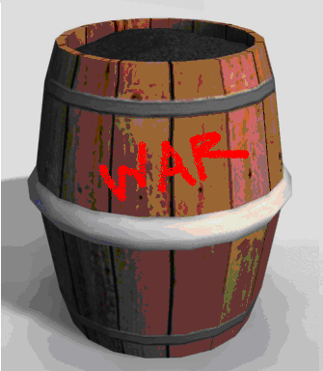

What ingredients were added to the powder keg?

One part _______________________________________________________

A dollop of _______________________________________________________

Two parts _______________________________________________________

A drizzle of _______________________________________________________

As each European nation added to the powder keg, tension and animosity amplified throughout Europe. The stage for war had been set but only lacked ______________________.

The assassination of Austrian Archduke ____________________________________ on June 28, 1914 set off a chain of events, ultimately leading to a full scale world war.

