Heather True and Samantha Arena

Teaching American History – Year 3

Scituate High School

**Citizenship Unit—Overview**

**Unit Goal**:

* To use historical events to exemplify the impact that individuals and groups can have in bringing about change and improving society.
* To empower students to engage in civic action in their own community.

**Why is this Unit Needed?**

Civic education is a crucial aspect to a functioning republic. Citizens must understand the components of the government they abide by to be able to participate in its government. Despite the importance of civics, knowledge of its’ crucial components is extremely low. According to a 1998 National Center for Education Statistics Civics Assessment of the United States, only six percent of eighth grade students were able to describe two ways that countries benefit from having a constitution (Wichowsky, 2002). Additionally, only nine percent of graduating high school seniors could list two ways democratic society benefits from the active participation of its citizens (Wichowsky, 2002). It is clear that American’s understanding of their government is extremely low. This decline can be attributed to the decreasing importance civics holds in the minds of the public. According to Galston (2007), in the mid-1960s, sixty percent of Americans said they thought it was important to stay informed of current politics; yet by 2000, that figure had deteriorated to thirty percent.

Despite these low scores, the United States does have many civic education programs. Winchowsky (2002) finds that seventy percent of United States schools report a civic-related subject graduation requirement. Unfortunately, Massachusetts is not one of them. At Scituate High School, students have limited exposure to these government and civic concepts with most instruction coming in the four week long government unit during their U.S. History course in sophomore year. In a sampling of our own classes, 60 sophomore students (38 females, 22 males) were given the U.S. Citizenship test before we began this unit. In order to pass students needed to have 6 correct answers out of 10 questions. The average score in our sample was 2/10 or only 20%. After taking the tests, students were frustrated and described the tests as “painful,” “embarrassing,” and were “really angry because we haven’t ever been taught this information and I think it should be more of a priority for teachers.” Although certainly developing a civics course would be a solution, in order to reach the most students we thought that it was imperative to link these concepts of government and the importance of civic responsibility to historical units within the U.S. History curriculum. We believe that in order to truly understand history, students must have a firm grasp in how the government works and how individuals and groups can bring about change at all levels. These are concepts that can be incorporated throughout the year into units such as Progressive Reformers, the New Deal, and the Civil Rights Movement.

**Our Initial Steps:**

1. After identifying the problems that exists at the national, state, and local levels, we began meeting to bring about a new citizenship focus as a departmental goal for this year. We have developed a graphic that outlines our goal of creating “Problem Solving Citizens” **(see Attachment 1)**. In order to be a problem solving citizen, all students must be tolerant of different perspectives, be able to think critically and evaluate information, be engaged to understand the issues and empowered to do something about them, and to be informed by their understanding of facts, ideas, and their own personal experiences. These skills are all also essential skills of being an historian. After drafting this graphic, we recognize that this does not change much of what we already do, but rather it gives us a clear goal and focus for our efforts.

1. To work toward this goal of creating problem solving citizens, we began to develop themes and essential questions for our U.S. History course. Throughout the year, we will focus our instruction on these themes.

Those themes that relate to this citizenship unit include:

1. Democratic citizenship requires active and responsible participation in local, national, and world constitutional systems.

* What does it mean to be an American?
* How can citizens create change?
* What rights and responsibilities do citizens have in a democracy?

1. The study of political, social and economic patterns reveals continuity and change over time which can have both positive and negative consequences.

* Is change beneficial?
* Which brings about more progress – gradual or immediate change?
* How does progress for some equal problems for others?

1. People resolve conflicts by choosing among various responses including aggression, compromise, and cooperation, each of which has immediate and long-term outcomes*.*

* How does the American government respond to opposition?
* Does war result in progress or problems?
* How are prejudice and bias created and how do we overcome it?

**The Unit:**

1. **Progressive Lesson—How can one person make an impact on society? (See Attachments 2 and Attachment 3)**

Students will evaluate how individuals can bring about change. Students will compare and contrast the photographs of Lewis Hine and Jacob Riis and evaluate each photographer’s goals, methods, and success in improving living and working conditions at the turn of the century.

1. **Civil Rights Lesson—How can groups bring about change? (See Attachment 4)**

Students examine how groups can bring about change. Students will represent the role of one major civil rights organization (NAACP, CORE, SNCC, SCLC, Black Panthers, and Nation of Islam) at a roundtable discussion about the future direction of the Civil Rights movement. Students will need to understand and accurately present the perspectives of the group, keeping in mind what groups they might agree and disagree with in terms of goals and tactics.

1. **Overview of the Service Project—Culminating activity (See Attachment 5)**

This is the culminating project completed at the end of junior year that will incorporate the concepts of civic action presented throughout the year. Students will identify problems that exist in the community and devise service projects to meet those needs and make an impact.

**Future Steps:**

1. Visit and observe other local schools and attend professional development seminars from groups like “We the People” to gather information and examples of their civic education and service learning programs.
2. Develop an additional research paper for first term in which students will research a problem that interests them. Students may use information from this research to begin to identify interests for projects later in the year.
3. Modify current New Deal lessons to focus on the role the government plays in making change, improving society, and impacting the lives of individuals.

**ATTACHMENT #1**

**The mission of the Scituate Social Studies Department is to develop the next generation of problem solving citizens**.

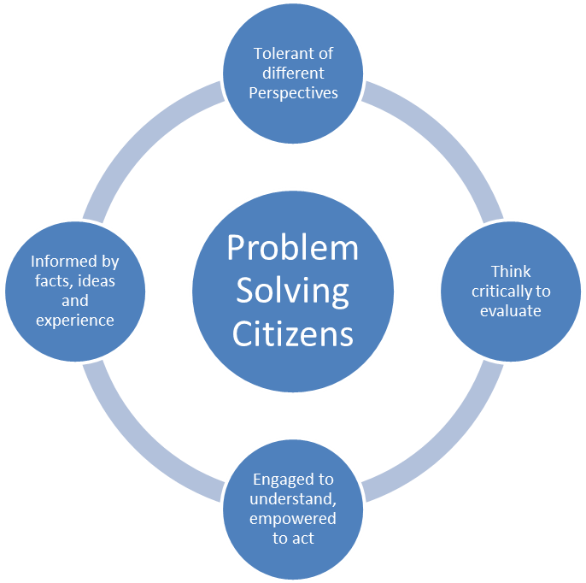

**ATTACHMENT #2**

**Lesson Plan: Progressive Reformers**

**Curriculum Framework Connection:**

USII.8 Analyze the origins of Progressivism and important Progressive leaders, and summarize the major accomplishments of Progressivism. (H, E)

**Unit Guiding Questions:**

* What is the role of the federal government?
* How can one person or group make an impact on society?

**Lesson Guiding Questions:**

* Who were Progressives and what was their goal?
* How did Lewis Hine and Jacob Riis attempt to make change?
* How were Lewis Hine and Jacob Riis’s photographs both similar and different?

Lesson Objectives:

The student will be able to:

* Assess who was included within the label Progressive and describe the various goals of the movement through a classroom discussion
* Explain the photographic techniques that Hine and Riis used in their images through a photographic drawing activity
* Decide how Hine and Riis’ photographs were both similar and different through a partner share

Lesson Plan:

1. Students will first answer an activator question, “Think of one person who you believe made a difference in society. Explain what they were attempting to change and how they went about accomplishing their goal.” Students will use the Think-Pair-Share method to describe their person to a partner and the class. The goal is to get students to see the various ways that one person can make a difference in society.
2. Students will then create a split page note taking segment in their notebook. As I show them the power point presentation with Hine and Riis’ photographs, I will ask them to write down answers to the following questions for each photographer.
   * What was the photographer’s goal in taking these pictures?
   * How does the photographer portray their subjects?
   * What details do you notice regarding the composition and background of the photograph?
   * How was this photographer attempting to make change in society?
3. After students have viewed the photographs and answered the questions in their notes, I will call on various students to share their answers. We will also discuss how Hine and Riis’ photographs are both similar and different and students will be asked to partner share their answers. Students will be urged to share their ideas and also discuss which photographer they think would be most effective. Students will be reminded about their end of the year civic project and how photography can lend itself to making change.
4. Before leaving class, students will draw a potential “photograph” in the style of Hine or Riis that displays the living conditions in city’s around 1900 to demonstrate what they have learned.

**ATTACHMENT #3**

**ATTACHMENT #4**

**Lesson Plan: Factions in the Black Revolution**

**Introduction:**

To have a complete understanding of historical events, students need to examine a variety of perspectives of those involved. In studying the Civil Rights Movement, most individuals could agree that African Americans deserved equal rights, however those involved differed in the specific goals, methods, and tactics used to achieve this. In the classroom, the most focus is often devoted to comparing and contrasting the non-violent methods of Martin Luther King and the more militant tactics of Malcolm X, however in fact the divisions were much more complicated than that. In his book, *Brown v. Board of Education and the Civil Rights Movement*, Michael Klarman discusses the “strained relations” that existed between the SCLC and NAACP. While both groups sought to use non-violent protest as a method, they varied in their tactics with SCLC preferring direct action and the NAACP advocating the use of litigation. As evidence of this tension, Thurgood Marshall, the leader of the NAACP, even called Martin Luther King a “’first rate rabble-rouser’” (Klarman 140).

**Curriculum Framework Connection:**

USII.25 Analyze the origins, goals, and key events of the Civil Rights movement. (H)

USII.26 Describe the accomplishments of the civil rights movement. (H, E)

**Unit Guiding Questions:**

* How can one person or group make an impact on society?
* Which brings about more progress—gradual or immediate change?

**Lesson Guiding Questions:**

* How were the goals of civil rights organizations (NAACP, SCLC, CORE, SNCC, Black Panthers, Nation of Islam) similar? How were they different?
* How were the methods and tactics used by civil rights organizations (NAACP, SCLC, CORE, SNCC, Black Pathers, Nation of Islam) similar? How were they different?
* What methods were successful? What methods were not? Why?

**Lesson Objectives:**

Students will be able to:

1. Identify the goals and tactics used by a variety of civil rights organizations.

2. Students will address the question—How do individuals and groups create change?

**Lesson Plan:**

1. Students will be assigned one group to research—NAACP, CORE, SCLC, SNCC, Black Panthers, and Nation of Islam. Students must find 3-5 sources to help them identify:
   1. Who are the key leaders/individuals involved?
   2. What have been the most important civil rights actions they are taken part in?
   3. What are the group’s goals? (must be more than desegregation, civil rights, or equality)
   4. What tactics does the group use to achieve its goals? Why?
   5. Describe the relationship between your group and the others listed. Make a generalization for each one—what will you agree with/disagree with.
2. Students will represent one of the civil rights groups at our “Round Table Discussion.” Groups should assign the roles of the key leaders to group members. All other group members should help provide support for the spokesperson(s) by providing them with information and guidance during the “Round Table Discussion.”

* NAACP—Roy Wilkins, Thurgood Marshall, Medgar Evers
* CORE—James Farmer, Bayard Rustin
* SCLC—Martin Luther King, Jr., Ralph Abernathy, Jesse Jackson, Andrew Young
* SNCC—John Lewis, Diane Nash
* Black Panther Party—Huey Newton, Bobby Seale
* Nation of Islam—Malcolm X, Elijah Mohammed

1. Groups will prepare a one-page persuasive statement from their group’s perspective that outlines:

* What is the biggest issue facing the movement today? Be specific.
* What tactics have worked well? Which have failed? Explain.
* What should be the next step in the movement? What action should you take?

1. At the Roundtable Discussion, students will represent the group’s perspective accurately, engage in discussion and debate with the other groups, and actively negotiate to establish a plan that reflects your goals and preferred tactics. At the end of the period, students should submit a “Next Steps Action Plan” to the teacher.
2. At the end of class, each student will review the “Next Steps Action Plan” that produced in the discussion and evaluate whether it meets the groups goals and preferred strategy. Students will also be asked to personally reflect on how groups can create change. What worked well? What was a struggle?

**ATTACHMENT #5**

**Overview of Civic Project**

Part I – Students will write a small research paper on one issue that faces the local, state, national or international community. These papers will be written during the 2nd or 3rd term and allow students to research in depth one particular issue that they think deserves attention.

Part II – Each student will summarize their research paper into a 5 minute Prezi presentation. This Prezi will allow students to share the issues they think are most critical to provide community service too. After all of the presentations, the class will discuss the various options and pick either one class project or a few issues that smaller groups would like to work on.

Part III – Students will complete a self-inventory of their strengths and weaknesses when working in a large group. Students will use this self-inventory to help assign roles within their group when deciding how to address the issue they have chosen.

Part IV – Students will work within their group to further research the problem and various solutions that have been attempted in the past by all levels of government (local, state, nation), organizations/interest groups, and individuals. Students will use this knowledge to guide how they wish to address the problem. Students should look at previous actions taken by all levels of government.

Part V – After students share the knowledge they have gathered they will create a project proposal. This proposal will introduce the community service project they wish to complete. Their proposal will include:

* A statement of the project’s goals. These should be specific and measurable.
* A description of the community need that exists
* A description of the action they would like to take
* A list of potential people or groups they could partner with and an explanation of how these groups would enhance their project
* Their intended audience of the project

Part VI – Students will create a list of items that need to be completed in order to finish their project. They will also create a timeline of when each item will get done and who will be responsible for each part. Students should use their self-inventory to help determine the role that each member will play in the group. This calendar will be placed on a group website so that all students can access it as needed.

Part VII – Students will work to implement their project using and adjusting their timeline and list of items to be completed.

Part VIII – Students will present the results of their project to the class. Perhaps an event could also be organized to present their work to the community, school board, superintendent, etc.

Part IV – Students will reflect on their experiences within the group and as an individual. They will also evaluate their level of success and make recommendations of what future groups could do differently. Students should also note next steps to helping improve this issue that could be used by future groups.

**ATTACHMENT #6**

**Works Cited**

Galston, W. (2007). Civic Knowledge, Civic Education, and Civic Engagement: A Summary of

Recent Research. *International Journal of Public Administration*, 30(6/7), 623-642.

Klarman, M. (2007). *Brown v. Board of Education and the Civil Rights Movement*. New York: Oxford University Press. Wichowsky, A. (2002). NACE : What Young People Know. NACE : *National Alliance for Civic*

*Education*.