Day One The Carter Years Name: _________________________ Date
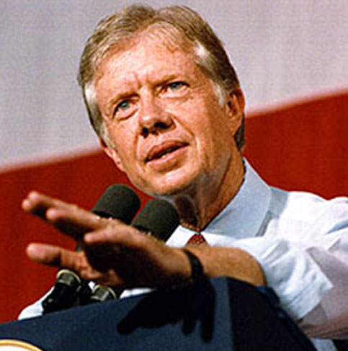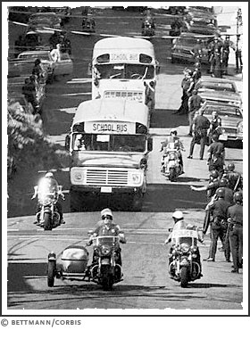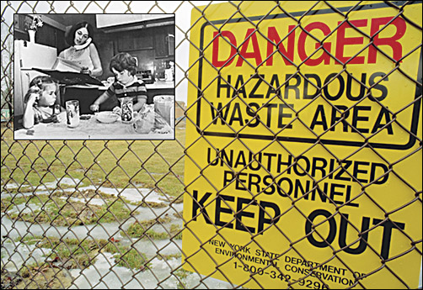
Starter Please Read Oil crisis 1973 and 1979
The 1973 oil crisis started in October 1973, when the members of Organization of Arab Petroleum Exporting Countries or the OAPEC (consisting of the Arab members of OPEC, plus Egypt, Syria and Tunisia) proclaimed an oil embargo. This was "in response to the U.S. decision to re-supply the Israeli military" during the Yom Kippur war. It lasted until March 1974.With the U.S. actions seen as initiating the oil embargo and the long term possibility of high oil prices, disrupted supply and recession, a strong rift was created within NATO. Additionally, some European nations and Japan sought to disassociate themselves from the U.S. Middle East policy. Arab oil producers had also linked the end of the embargo with successful U.S. efforts to create peace in the Middle East, which complicated the situation. To address these developments, the Nixon Administration began parallel negotiations with both Arab oil producers to end the embargo, and with Egypt, Syria, and Israel to arrange an Israeli pull back from the Sinai and the Golan Heights after the fighting stopped. By January 18, 1974, Secretary of State Henry Kissinger had negotiated an Israeli troop withdrawal from parts of the Sinai. The promise of a negotiated settlement between Israel and Syria was sufficient to convince Arab oil producers to lift the embargo in March 1974. By May, Israel agreed to withdraw from some parts of the Golan Heights.

How did America’s foreign policy impact our ability to acquire oil? __________________________________________
_________________________________________________________________________________________________
Industrialized economies relied on crude oil, and OPEC was their predominant supplier. Because of the dramatic inflation experienced during this period, a popular economic theory has been that these price increases were to blame, as being suppressive of economic activity. A minority dissenting opinion questions the causal relationship described by this theory. The targeted countries responded with a wide variety of new, and mostly permanent, initiatives to contain their further dependency. The 1973 "oil price shock", along with the 1973–1974 stock market crash, have been regarded as the first event since the Great Depression to have a persistent economic effect.
The 1979 (or second) oil crisis in the United States occurred in the wake of the Iranian Revolution. Amid massive protests, the Shah of Iran, Mohammad Reza Pahlavi, fled his country in early 1979 and the Ayatollah Khomeini soon became the new leader of Iran. Protests severely disrupted the Iranian oil sector, with production being greatly curtailed and exports suspended. When oil exports were later resumed under the new regime, they were inconsistent and at a lower volume, which pushed prices up. Saudi Arabia and other OPEC nations, under the presidency of Dr. Mana Alotaiba increased production to offset the decline, and the overall loss in production was about 4 percent. However, a widespread panic resulted, added to by the decision of U.S. President Jimmy Carter to order the cessation of Iranian imports, driving the price far higher than would be expected under normal circumstances. In April of the same year, President Carter began a phased deregulation of oil prices. At the time, the average price of crude oil was $15.85 per barrel (42 gallons). Deregulating domestic oil price controls allowed U.S. oil output to rise sharply from the Prudhoe Bay fields, although oil imports fell sharply. Long lines once again appeared at gas stations and convenience stores, just as they did in 1973.

What was happening to the American economy because of the events in the Middle East? _________________________
__________________________________________________________________________________________________
PPT The 70s Please fill in the Blanks
Jimmy Carter was from? _______________________ His prior experience? __________________________
What religion? ____________________________
President Carter’s challenges and troubles: ____________________________________________________
______________________________________________________________________________________________________________________________________________________________________________
What are the feelings of the American people?_________________________________________________
______________________________________________________________________________________________________________________________________________________________________________
What environmental issues does the country have? ______________________________________________
______________________________________________________________________________________________________________________________________________________________________________
What is happening to our economy? __________________________________________________________
______________________________________________________________________________________________________________________________________________________________________________
What is the Rustbelt? _____________________________________________________________________
_______________________________________________________________________________________
Watch the Century The Carter Years V 6 22 Minutes
1. What countries were challenging America? __________________________________________________
2. What happened to the American auto industry? _______________________________________________
_______________________________________________________________________________________
3. Foreign cars had what % of the American market ?_______________________________
4. What changes were the American people going through? _______________________________________
_______________________________________________________________________________________
5. What was Hooker Chemical Company doing? _______________________________________________
______________________________________________________________________________________
6. What happened to the value of the homes in the “Love Canal” Buffalo area? _______________________
_______________________________________________________________________________________
7. What happened to 2 EPA agents? __________________________________________________________
8. How did South Boston react to orders to integrate their public schools? ____________________________
_______________________________________________________________________________________
9. What % of students stopped going to Boston Public Schools? ____________________________________
10. What was happening to American Society? _________________________________________________
_______________________________________________________________________________________
11. What happened to Mayor Moscone and Harvey Milk? ________________________________________
_______________________________________________________________________________________
12. What was the “Twinkie Defense” _________________________________________________________
_______________________________________________________________________________________
13. Was Iran stable? ______________________________________________________________________
14. What happened at 3 Mile Island? _________________________________________________________
_______________________________________________________________________________________
15. What happened to oil prices? ____________________________________________________________
16. What did Jimmy Carter try to do at his Camp David meeting? __________________________________
_______________________________________________________________________________________
17. What did President Carter say in his “Malaise Speech” ? ______________________________________
_______________________________________________________________________________________
18. What did he do to his cabinet? ___________________________________________________________
_______________________________________________________________________________________
***************************************************************************************
Think about it! List some ways the late 1970’s problems were similar to the American problems of today:
________________________________________________________________________________________________________________________________________________________________________________________________________________________________________________________________________________________________________________________________________________________________________
Why were the Carter Years different to what we are going through today? ___________________________
________________________________________________________________________________________________________________________________________________________________________________________________________________________________________________________________________________________________________________________________________________________________________

